1. **Beginners Challenge:** Tell me a joke

Print out one of the sentences below:

* 42.9% of statistics are made up on the spot
* Honk if you love peace and quiet
* Error. No keyboard. Please hit F5 to continue
* Whoever stole my copy of Microsoft office, you will pay. You have my Word.

1. **Intermediate Challenge:** Mad Libs

Mad Libs is a game where users fill in the blanks to a short story

Create a Mad Libs game using one of the templates below

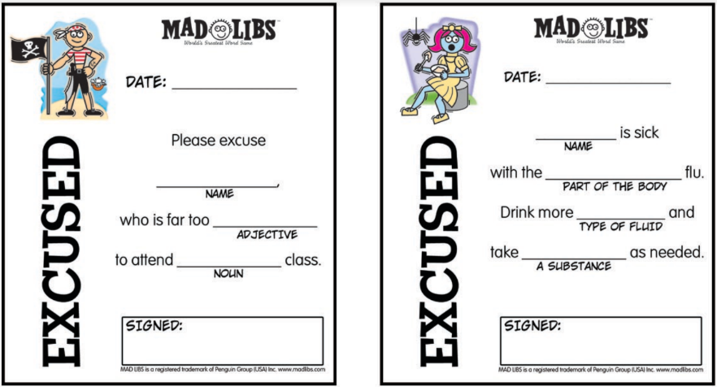

Source: https://docs.google.com/viewer?url=http%3A%2F%2Fwww.madlibs.com%2Fcontent%2Fuploads%2F2016%2F04%2FKIDS-excuse-hall-pass_1_.pdf

1. **Advanced Challenge:**

Create a program that asks user to input the width and height of a square.

The program should output the perimeter and area of a square

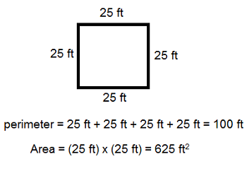

1. **Advanced Challenge: Convert Pay Rate**

Ask user to input their hourly rate. Convert it to a daily, hourly and annual salary.

Hint: Employees work 8 hours a day, 40 hours a week, and 2080 hours a week.

Compare your results to www.hourlysalaries.com

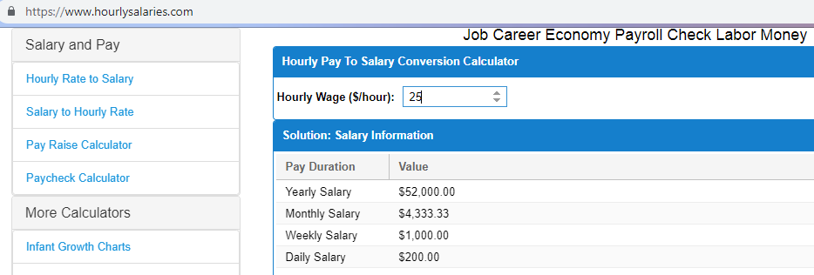

**Homework:**

1. Create a program that asks user for their address and stores it with variable name addr  
   Convert their address to all upper case and print it to the console
2. Create a program that asks users for their phone number.

Remove all dashes from the phone number they enter and print the number to the console

Hint: Use the replace() function in lesson 1.4 additional resources

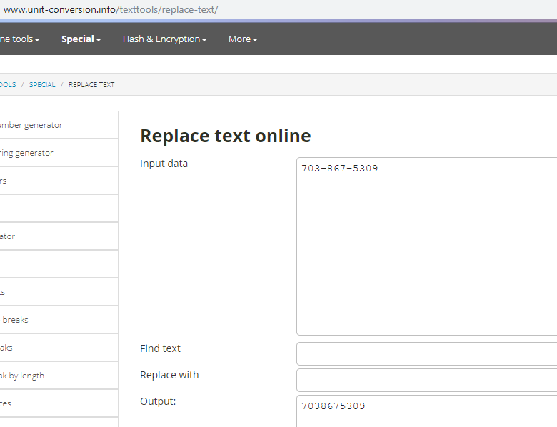

1. **Create a program that converts hours to minutes**

